RAKSHA

Real-time AI Knowledge Screening & Hazard Audit
User Manual
For employees with role: User

Field | Details
Product | RAKSHA
Document | User Manual
User Role | Employee / User
Version | 1.0
Release Date | September 2026
Document Owner | YesPanchi Tech Services
Classification | Internal / Confidential
Applicable Platform | Web Application + Browser Guard

Contents

- What is RAKSHA and User’s Privileges
- How to open RAKSHA (connect)
- Login (Sign In)
- Create account / Request Access
- Forgot password + OTP
- Forgot username
- After login
- Prompt Repository: Your prompts
- Prompt Repository: Chat History & New Chat
- Prompt Repository: Playground (chat screen)
- Prompt Repository: Run / Add / Stop / files / voice
- Copy text from chat
- Logout
- Browser Guard
- Browser Guard: install (Windows)
- Browser Guard: install (Mac)
- Problems & who to call

What is RAKSHA and User’s Privileges

Real-time AI Knowledge Screening & Hazard Audit (RAKSHA) is an enterprise platform designed to provide controlled access to AI capabilities while helping organizations govern browser-based AI usage, approved AI models, prompts, and user interactions.
For employees, RAKSHA provides a controlled workspace where users can:
- Access administrator-approved prompts
- Chat with the AI model your admin set on each prompt
- Maintain chat history
- Upload permitted files
- Use voice input where enabled
- Copy AI-generated content for approved business activities
- Use company-managed Browser Guard protection when deployed
This manual is only for the User role (employee).
Admins use a different manual.
You CAN: | You CANNOT (Admin / IT only):
- Open RAKSHA in a browser and Sign In / Sign Up / reset password with OTP  - Use Prompt Repository: pick prompts Admin assigned, chat with the prompt’s model using Run, keep Chat History  - Attach files, record voice, copy chat text for your work  - Install RAKSHA Guard on your laptop when IT sends the Windows or Mac ZIP  - Logout when you finish | - Open Dashboard, Logs, Browser AI tabs, Models, MCP, Governance, Settings, or other sidebar menus  - Create / rename / delete prompts or folders, or Commit Version  - Add Target domains, Guard Rules, API keys, SMTP, users, or budgets  - Export Prompt Logs / Search Logs / company reports  - Remove or turn off Browser Guard yourself (ask IT if needed)

Admin must prepare your account
1) Accept your signup
2) Assign Allowed Prompt Repositories
3) Assign a Virtual Key (to you, your team or customer)
4) Commit a provider/model on each prompt. Without these, you may Sign In but see empty list or cannot Run.
Remember
After login you always land on Prompt Repository. Seeing only that menu is normal, It is not a bug.

How to open RAKSHA (connect)

RAKSHA is a company website. You do not install the dashboard; you only open it in a browser.

What you see on screen:
  - Browser address bar with the company URL from IT
  - Sign In page at /login
  - Links: Sign Up, Forgot password? and Forgot your username?

Fields / buttons (what each does):
  - Company URL : Example: https://your-company.example.com, ask IT admin for the exact link
  - Sign In page : Shows the Username and Password fields when the site is healthy

How (step-by-step):
- Get the company RAKSHA URL from IT / HR (bookmark it).
- Open Chrome, Edge, or Firefox.
- Paste the URL and then press Enter.
- You should see the Sign In page.
What happens after
Stay on Sign In until you log in, request access, or use Forgot password / Forgot username.

Example
https://your-company.example.com - Sign In screen with Username, Password, Sign In.

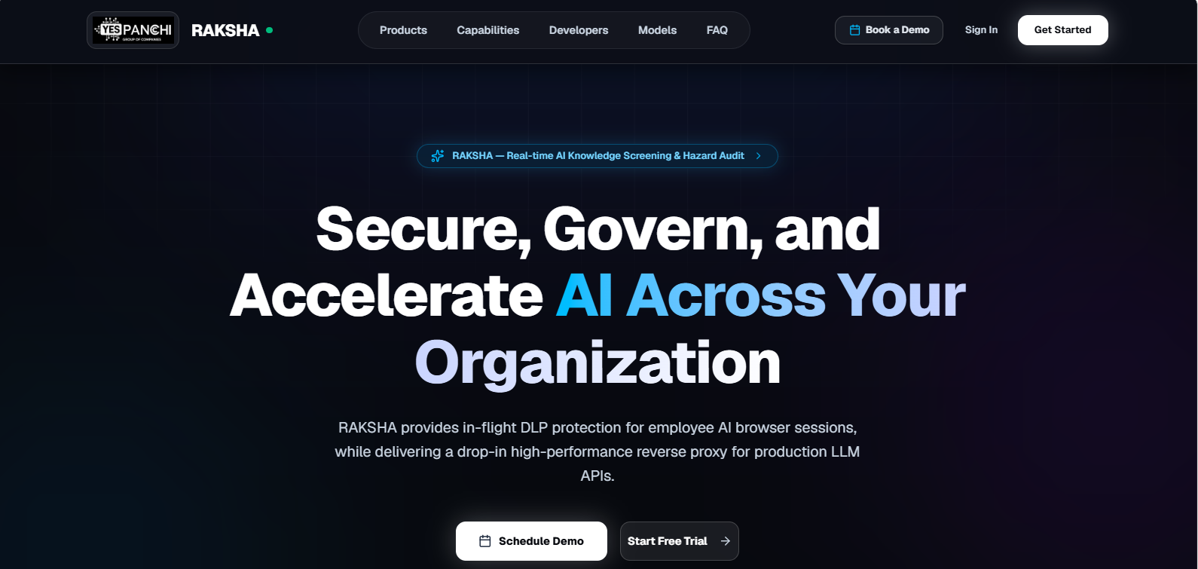

Login (Sign In)

What you see on screen:
  - Title: Sign In
  - Fields: Username, Password (eye icon to show/hide)
  - Button: Sign In
  - Links: Sign Up (top right, next to “Don't have an account?”), Forgot password?, Forgot your username?

Fields / buttons (what each does):
  - Username : Login name from IT or from sign-up; not always the same as your email
  - Password : Case-sensitive; the eye icon shows or hides it. 3 wrong tries lock Sign In for about 20 minutes (Forgot password? unlocks it)
  - Sign In : Checks your credentials; on success the User role opens Prompt Repository
  - Sign Up : Goes to Create Account / Request Access
  - Forgot password? : Email OTP flow to set a new password
  - Forgot your username? : Emails your username to your registered email address

How (step-by-step):
- Open the company URL (/login).
- Type Username.
- Type Password.
- Click Sign In.
- The User role lands on Prompt Repository (/workspace/prompt-repo).
What happens after
Wrong password shows an error and you stay on login. Pending (not Accepted) accounts cannot Sign In, If so, wait for Admin or contact IT. Use Logout when finished.
Example
Username: ravi.kumar · Password: (yours) · Sign In to Prompt Repository opens.

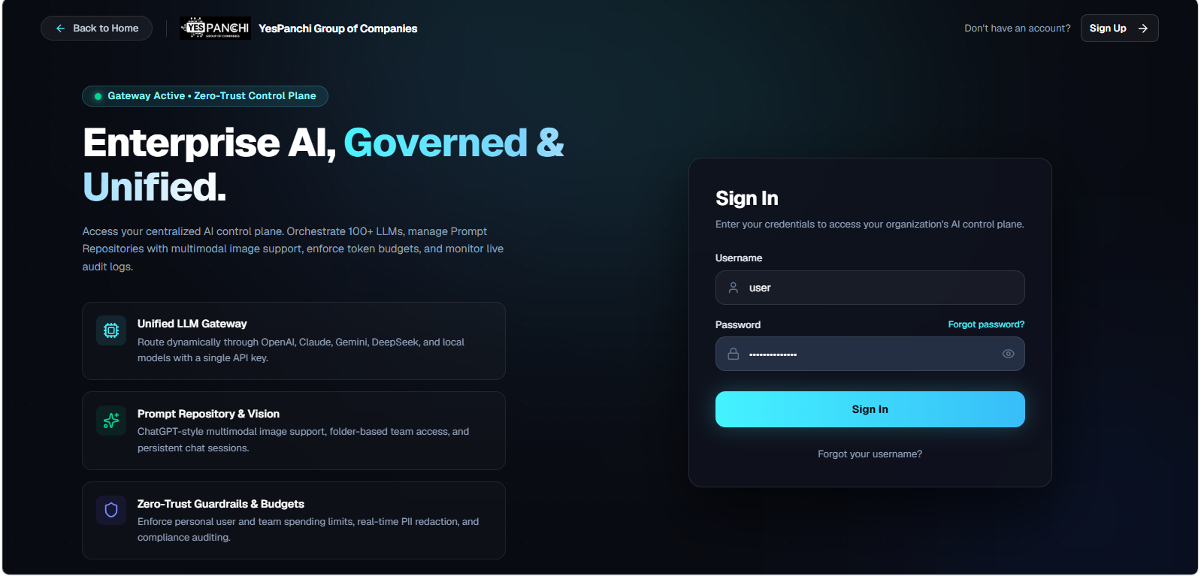

Create account / Request Access

New employees request a User account. An Admin must accept you before Sign In works.

What you see on screen:
  - Page title: Create Account at /signup
  - Fields: Username, Email Address, Password, Confirm Password
  - Button: Request Account Access
  - Success: Submitted for Admin Approval + Continue to Sign In

Fields / buttons (what each does):
  - Username : Unique login name you will use on Sign In
  - Email Address : Use your real work inbox; OTP codes and admin messages are sent here
  - Password : Must meet the policy: 8+ characters, uppercase, lowercase, number and symbol
  - Confirm Password : Must match Password
  - Request Account Access : Sends your request with role User; you cannot use RAKSHA until an Admin accepts it
  - Continue to Sign In : Returns to /login after the success message

How (step-by-step):
- On Sign In, click Sign Up (or open /signup).
- Fill Username, Email Address, Password, Confirm Password.
- Click Request Account Access.
- If email verification is on, first enter the 6-digit Verification Code from your email and click Verify & Complete.
- Read the success message: Submitted for Admin Approval.
- Wait for an Admin to Accept (or Deny) your request under Governance → Users.
- After you are accepted, click Continue to Sign In and sign in with your username and password.
What happens after
Denied | Sign In fails; contact HR/IT. Accepted
Accepted | Sign In works and you see Prompt Repository only.

Example
Email: ravi.kumar@company.com · Username: ravi.kumar · Request Access and wait for Accept.

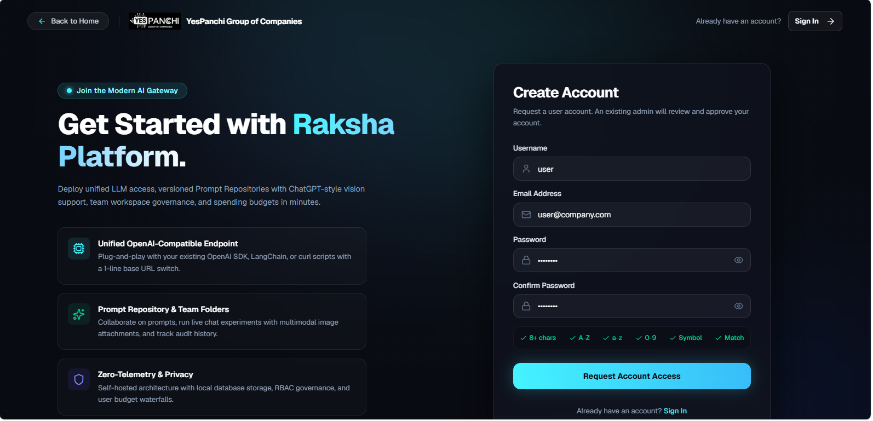

Forgot password + OTP

Use this when you forgot your password. There is no Change Password screen inside Prompt Repository; always use Forgot password? on /login.

What you see on screen:
  - Step A : Forgot Password: field Email Address or Username, button Send Verification Code
  - Step B : Reset Password: Verification OTP Code, Verify Code, Resend Code, New Password, Confirm New Password, Update Password
  - Link: Back to Sign In (on Step B: Back to forgot password)

Fields / buttons (what each does):
  - Email Address or Username : Your RAKSHA username or the email on your account
  - Send Verification Code : Emails a one-time code (check spam); then the Reset Password screen opens
  - Verification OTP Code : 6-digit code from the email
  - Verify Code : Must succeed before New Password unlocks; a wrong code shows an error
  - Resend Code : Sends a new code after a cooldown (shows “Resend in Ns”, about 2 minutes)
  - New Password / Confirm New Password : Rules: 8+ characters, uppercase, lowercase, number and symbol; both must match
  - Update Password : Saves the new password; then return to Sign In
  - Change (in the Target Account box) : Goes back to re-enter your email or username

How (step-by-step):
- On /login click Forgot password?.
- Enter your email or username and click Send Verification Code.
- Open the email and copy the OTP.
- Paste it into Verification OTP Code and click Verify Code (wait for Verified).
- Enter New Password and Confirm New Password, then click Update Password.
- Sign In with your username + new password.
Example
Email: you@company.com · OTP verified · New password set and Sign In works.
What happens after
Old password stops working immediately. No email, Need to ask Admin/IT (company SMTP) and check spam.

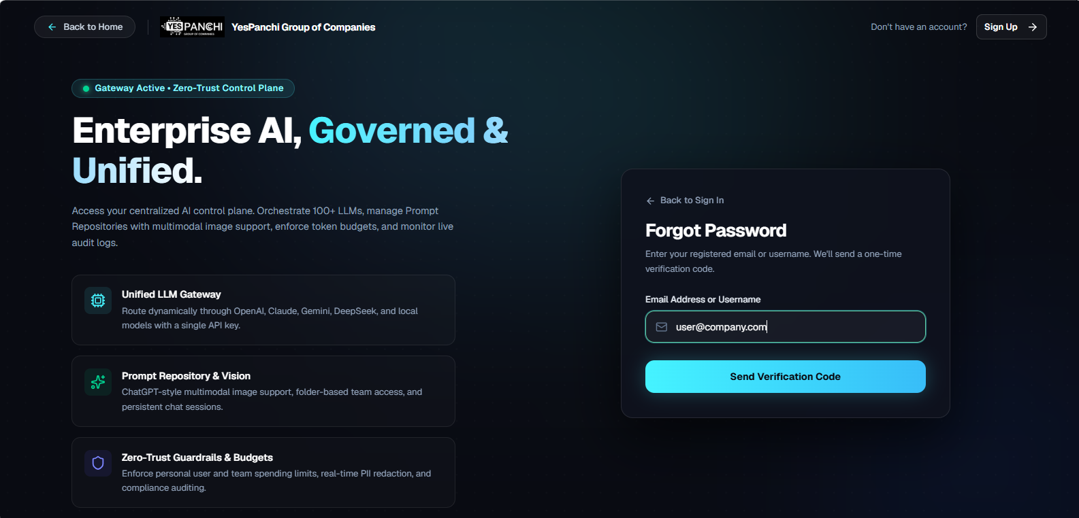

Forgot username

What you see on screen:
  - Title: Forgot Username
  - Field: Email Address
  - Button: Retrieve Username
  - Link: Back to Sign In

Fields / buttons (what each does):
  - Email Address : Email stored on your account (same as sign-up)
  - Retrieve Username : Emails your username to that inbox if the account exists

How (step-by-step):
- On /login click Forgot your username?.
- Enter your email address and click Retrieve Username.
- Check inbox (and spam) for your username.
- Return to Sign In, enter your username + password and click Sign In.
Example
Email: priya@company.com → mail shows Username: priya.sharma.
What happens after
This flow does not change your password ,just recovers username.

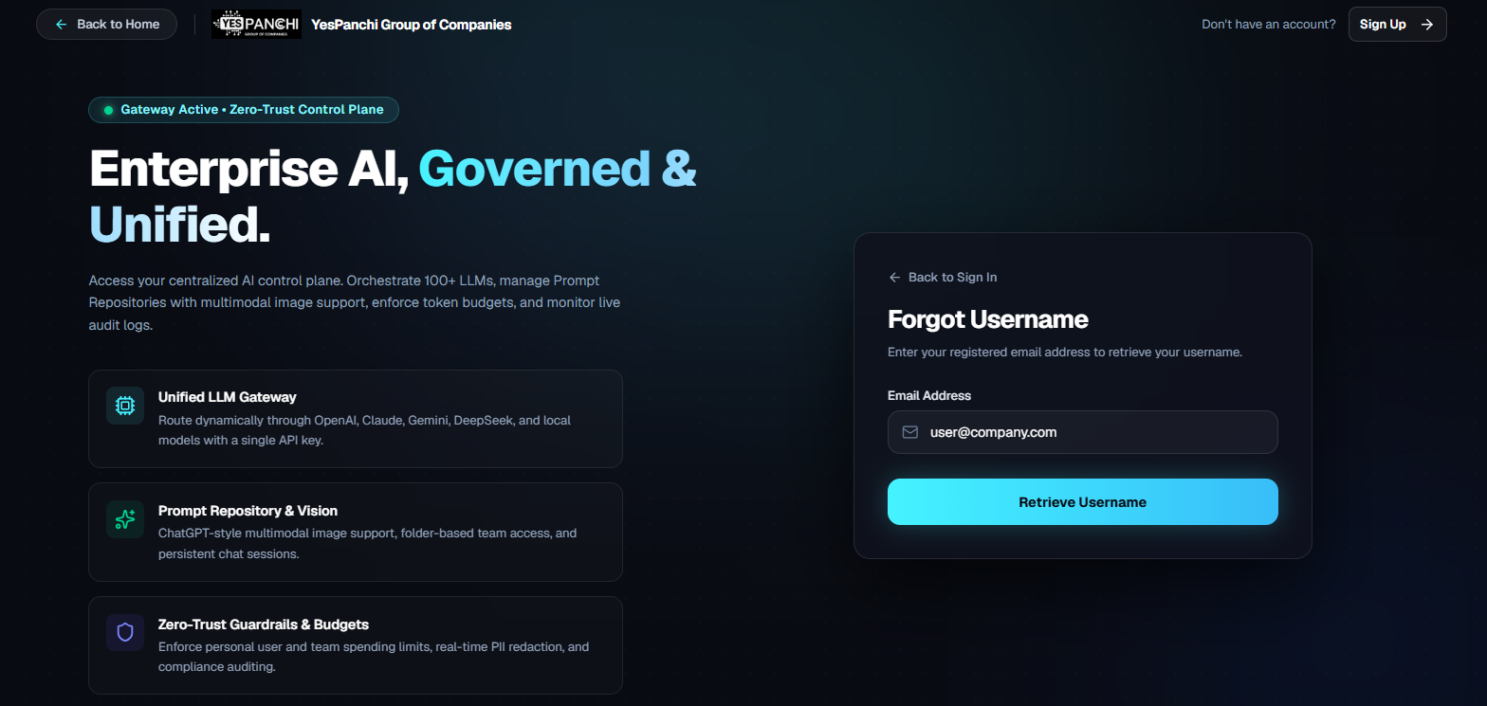

After login

As User you are locked to Prompt Repository. Other product menus are hidden on purpose.

What you see on screen:
  - Left sidebar: only Prompt Repository (plus Search... for that item)
  - Theme toggle (light/dark) and your username
  - Logout control
  - Main area: Prompt Repository (Your prompts + Chat History + playground)

Fields / buttons (what each does):
  - Prompt Repository (nav) : Your only workspace screen, opens /workspace/prompt-repo
  - Search... : Finds sidebar items; for User it only finds Prompt Repository
  - Theme : Switches the light/dark look; does not change permissions
  - Logout : Ends the session and returns to Sign In

How (step-by-step):
- After Sign In, confirm the URL is Prompt Repository.
- Confirm sidebar shows only Prompt Repository.
- If you see a “You don't have permission” message, ask Admin to grant Prompt Repository View.
- If the list is empty, Admin must set Allowed Prompt Repositories on your user.
Example
Sidebar: Prompt Repository only · Center: Your prompts list · Bottom: chat composer after you pick a prompt.
What happens after
Opening any other /workspace/… URL redirects you back to Prompt Repository.

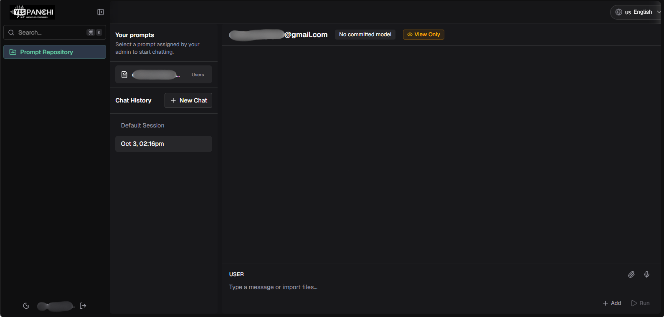

Prompt Repository : Your prompts

Left panel section Your prompts lists only prompts Admin assigned to you. You do not create folders or new prompts.

What you see on screen:
  - Heading: Your prompts
  - Subtext: Select a prompt assigned by your admin to start chatting.
  - Rows: prompt name with file icon (its folder name is shown on the right)
  - Empty: No prompts assigned. Ask your admin to allow prompt repositories on your user.
  - Or full-page empty: No prompts available

Fields / buttons (what each does):
  - Your prompts (list) : Click a name to open that prompt in the playground
  - First prompt : Often auto-selected when the list loads
  - No prompts assigned : Admin must edit your user → Allowed Prompt Repositories

How (step-by-step):
- Look at the left panel; you will see Your prompts.
- Click the prompt you need (example: “Polite delay email”).
- The header shows the prompt name and the model badge (example: OPENAI — gpt-4o).
- If the list is empty, stop and ask Admin (do not try other menus).
Example
Your prompts: Polite delay email · Sales FAQ · Click Polite delay email → playground opens.
What happens after
Selecting a prompt loads its committed version. You cannot change provider/model.

Prompt Repository: Chat History & New Chat

What you see on screen:
  - Section: Chat History
  - Button: New Chat
  - Session rows (date/time labels; oldest at the top, newest at the bottom)
  - Empty: No chat history yet or Select a prompt above first

Fields / buttons (what each does):
  - New Chat : Starts a fresh session for the selected prompt; toast: New chat started
  - Chat History row : Reopens that conversation; your latest chat opens automatically when you pick a prompt
  - Auto-save : After you Run, the session is saved into Chat History (no separate Save button for User)

How (step-by-step):
- Select a prompt under Your prompts first.
- Click New Chat for a blank conversation.
- Or click an older row under Chat History to continue.
- Type and Run (next sections) and history updates after Run.
Example
New Chat - type question - Run - later reopen from Chat History by date label.
What happens after
New Chat is disabled until a prompt is selected. History is per your account and prompt.

Prompt Repository: Playground (chat screen)

What you see on screen:
  - Top: prompt name (or Playground) + model badge (PROVIDER — model) + View Only badge
  - Clear (trash) after you add a message
  - Message list: your messages and assistant replies (system messages are hidden from you)
  - Bottom composer: role dropdown, paperclip, mic, text box, Add, Run / Stop
  - No Settings panel for User: the model and key are set by your admin

Fields / buttons (what each does):
  - Model badge : Shows the provider and model the prompt runs on (committed by your admin); “No model selected” if none
  - Clear : Clears the conversation on screen (use carefully)
  - User / Assistant messages: You can edit or delete when the UI shows those controls
  - View Only badge : You can chat, but you cannot edit, save or commit the prompt
  - Composer textarea : Placeholder: Type a message or import files...
  - Key (automatic) : RAKSHA uses a key assigned to you, your team or your customer that still has budget; you do not pick it

How (step-by-step):
- Select a prompt (and optionally click New Chat).
- Check the model badge in the header. The prompt’s committed model is used; you cannot change provider/model.
- If no key is assigned to you, company default keys are used automatically.
- Type in the composer (details in next section).
- Use Clear only when you want to wipe the current thread view.
Example
Header: Polite delay email,OPENAI (gpt-4o), Composer ready at bottom.
What happens after
If you see “No prompt selected”, pick one from Your prompts in the sidebar.

Prompt Repository: Run / Add / Stop / files / voice

This is how you send messages. The prompt’s committed model and your assigned key are used automatically.

What you see on screen:
  - Role dropdown: USER / ASSISTANT (for new input)
  - Paperclip: Import files
  - Mic: Record voice / Stop recording
  - Buttons: Add, Run, Stop (while streaming)
  - Drag-drop: Drop files to attach

Fields / buttons (what each does):
  - Import files : Attach images, PDF, Office, zip, audio (max 20 MB per file)
  - Record voice: Records audio to attach; needs mic permission / HTTPS
  - Add : Puts your text/files into the thread without calling the model yet (toast: Message added)
  - Run : Sends chat to the model (Enter without Shift also runs); tooltip: Run prompt
  - Stop : Cancels generation while the assistant is streaming
  - Key : A key assigned to you directly, through your team, or through your customer is used automatically (one that still has budget)
  - Run disabled : The prompt has no committed model (tooltip: “Select a key and a model in Settings to run”); ask Admin to commit one

How (step-by-step):
- Select a prompt and, optionally, click New Chat.
- Check the header shows a model (not “No model selected”).
- Type your message (or Import files / Record voice).
- Optional: click Add to stage the message, then Run.
- Or click Run (or press Enter) to send immediately.
- Wait for the assistant reply; click Stop if you need to cancel.
- Session auto-saves into Chat History after Run.
Example
Type: “Rewrite this delay email politely”, Run ,assistant reply appears,history saved.
What happens after
Run disabled / toast about committed model or headers → contact Admin (you have no Settings panel to fix it).

Copy text from chat

Users do not get an Export PDF/Excel button. Copy text manually from the chat.

What you see on screen:
  - Assistant / user message bubbles in the playground
  - No Export menu on Prompt Repository for User role

Fields / buttons (what each does):
  - Select + Copy : Highlight text and Ctrl+C (Windows) or Cmd+C (Mac)
  - Paste : Paste only into tools your company allows

How (step-by-step):
- Open the chat message you need.
- Select the text with the mouse.
- Copy (Ctrl+C / Cmd+C).
- Paste into your approved app (email, ticket, doc).
- Never paste secrets, API keys, or customer PII into public AI websites.
Example
Select assistant reply, Copy, paste into Outlook draft.
What happens after
Company Prompt Logs / Search Logs export is Admin-only under Browser AI is not available to User.

Logout

What you see on screen:
  - Username shown near the bottom/side of the shell
  - Logout icon or control

Fields / buttons (what each does):
  - Logout : Ends your session and returns you to Sign In

How (step-by-step):
- When finished working, click Logout.
- Confirm you are back on the Sign In page.
- On a shared PC, always Logout and do not leave Prompt Repository open.
Example
Click Logout → /login appears → next person must Sign In with their own account.
What happens after
There is no in-app Change Password,You can use Forgot password on /login if needed.

Browser Guard

Browser Guard is a small program on your laptop. It is not a menu inside Prompt Repository. IT installs it so company policy applies when you use AI websites in Chrome, Edge, Firefox, Brave or Safari (Mac). RAKSHA Browser Guard is a company-managed endpoint component that helps enforce organizational controls when employees access AI websites through supported browsers.
Browser Guard may:
- Monitor approved AI-site activity
- Apply organizational rules
- Block restricted activity
- Warn users about restricted actions
- Add a redaction or warning note to risky content where configured

What you see on screen:
  - You receive a ZIP from IT (Windows or Mac), not from the User website menus
  - After install, Guard runs in the background
  - You still use normal browsers; Guard may block, warn about, or flag risky text

Fields / buttons (what each does):
  - RAKSHA Guard (laptop) : The agent IT gives you; it is separate from the Prompt Repository chat
  - Company AI sites : Sites IT monitors (example: chatgpt.com); follow IT’s list

How (step-by-step):
- Wait for IT email / ticket with the correct OS ZIP.
- Install using the Windows or Mac section below.
- Do not look for Guard settings under Prompt Repository; they are not there for User.
Example
IT sends Raksha_Guard_Windows.zip ,Click install and then continue daily work in browser + Prompt Repository.
What happens after
If Guard blocks a message, stop and ask Admin which rule fired and do not try to bypass proxy/PAC.

Browser Guard: install (Windows)

What you see on screen:
  - File from IT: Raksha_Guard_Windows.zip
  - Inside: Raksha_Guard_Setup.exe (plus INSTALL_WINDOWS.txt and support files; run Setup.exe)

Fields / buttons (what each does):
  - Raksha_Guard_Setup.exe : Run the installer and finish the wizard (no admin rights needed)
  - Quit browsers : Required so the Guard proxy/PAC applies; close every Chrome/Edge/Firefox window

How (step-by-step):
- Download Raksha_Guard_Windows.zip from IT.
- Extract the whole ZIP (do not run Setup from inside the ZIP).
- Run Raksha_Guard_Setup.exe, keep “Start automatically at Windows login” checked and click Finish.
- Fully quit Chrome, Edge, and Firefox (Task Manager if a window stays).
- Reopen the browser and open the AI site IT listed for a quick test.
Example
Setup.exe done , quit all browsers, reopen Edge, open chatgpt.com for IT test.
What happens after
Guard runs in the background. If sites work but IT sees no activity, browsers were probably not fully quit , quit again and retry.

Browser Guard: install (Mac)

What you see on screen:
  - File from IT: Raksha_Guard_macOS.zip
  - Inside: Install_Raksha_Guard.command and Raksha_Guard.app (and Raksha_Guard_Setup.pkg if IT includes it)

Fields / buttons (what each does):
  - Install_Raksha_Guard.command : Install script; double-click it (if macOS blocks it: right-click → Open → Open)
  - Raksha_Guard.app : The Guard app; the install script copies it to Applications and starts it
  - macOS permission dialogs : Allow when asked so Guard can work

How (step-by-step):
- Download Raksha_Guard_macOS.zip.
- Unzip it, keep all files together, and double-click Install_Raksha_Guard.command (or run Raksha_Guard_Setup.pkg if IT provides it).
- Allow any macOS security / network prompts IT expects.
- Fully quit Safari, Chrome, Edge, Firefox (Force Quit if needed).
- Safari users: turn off iCloud Private Relay.
- Reopen the browser and test the AI site IT named.
Example
Install_Raksha_Guard.command, Force Quit browsers, reopen the browser and test.
What happens after
Same as Windows: incomplete quit is the usual reason Guard does not apply.

Problems & who to call

  - Cannot Sign In / pending : Ask Admin to Accept your Request Access (or recreate account if Denied).
  - Forgot password / no OTP email : Use Forgot password?; check spam; if still none, Admin must fix SMTP.
  - Forgot username : Click Forgot your username?, enter your Email Address, then Retrieve Username.
  - Only Prompt Repository in sidebar : Normal for User role.
  - No prompts available / No prompts assigned : Admin must set Allowed Prompt Repositories on your user.
  - Cannot Run / No model selected : Admin must commit a provider/model on the prompt.
  - Budget limit reached : Your personal, key, team or customer budget is used up; ask Admin.
  - AI site blocked or warned : This is a Guard rule; ask Admin if you need access. Do not disable the proxy.
  - Guard install problem / certificate warning : Contact IT with your OS (Windows/Mac). Do not remove Guard yourself (uninstall needs a company key).
  - Need password change while logged in : Logout and Forgot password on /login (no in-app password page).
Who to call
Login / prompts / Run and Admin or App owner. Laptop Guard ZIP / install and IT desktop support.

